INOVA WEB APPLICATION TESTING PROCESS TRAVEL MODULE
- Travel> Expense Type: - Working
I have added the Expense Type entry data. Finally, the save button click is not working. Please check.
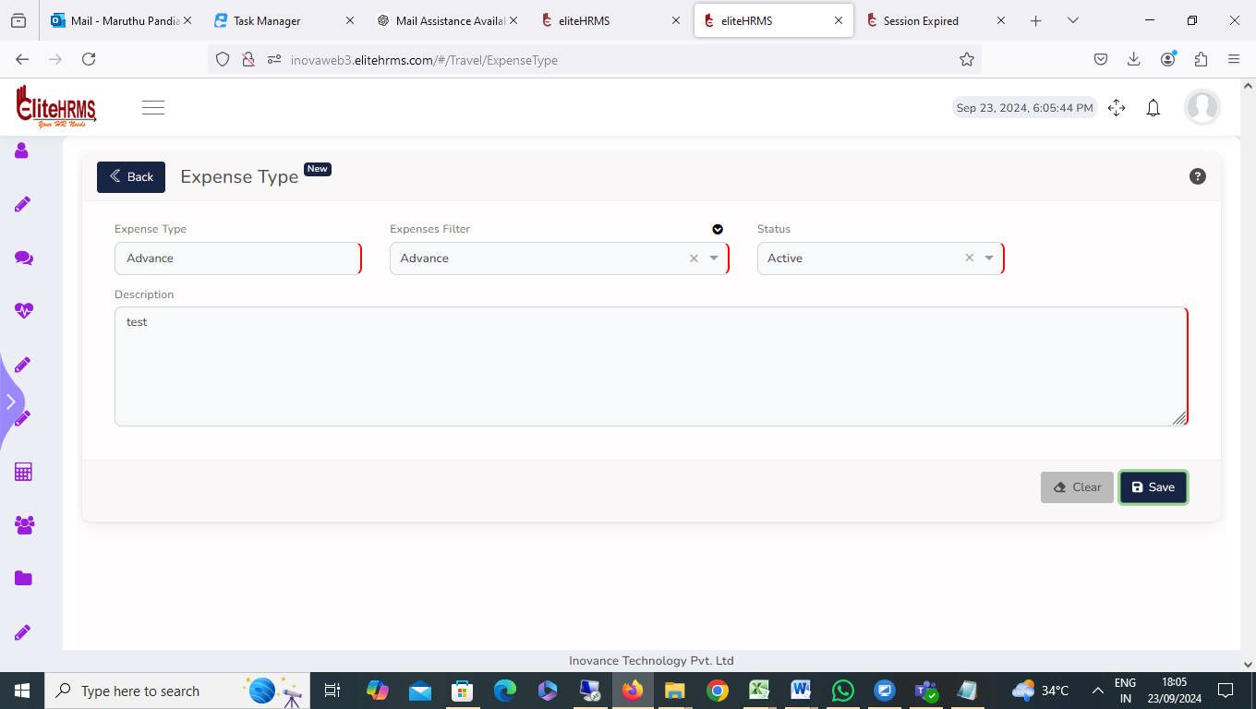

- Travel> Travel Rule Engine: - Working
Travel Rule Engine Eligibility Mode details not visible. Please check
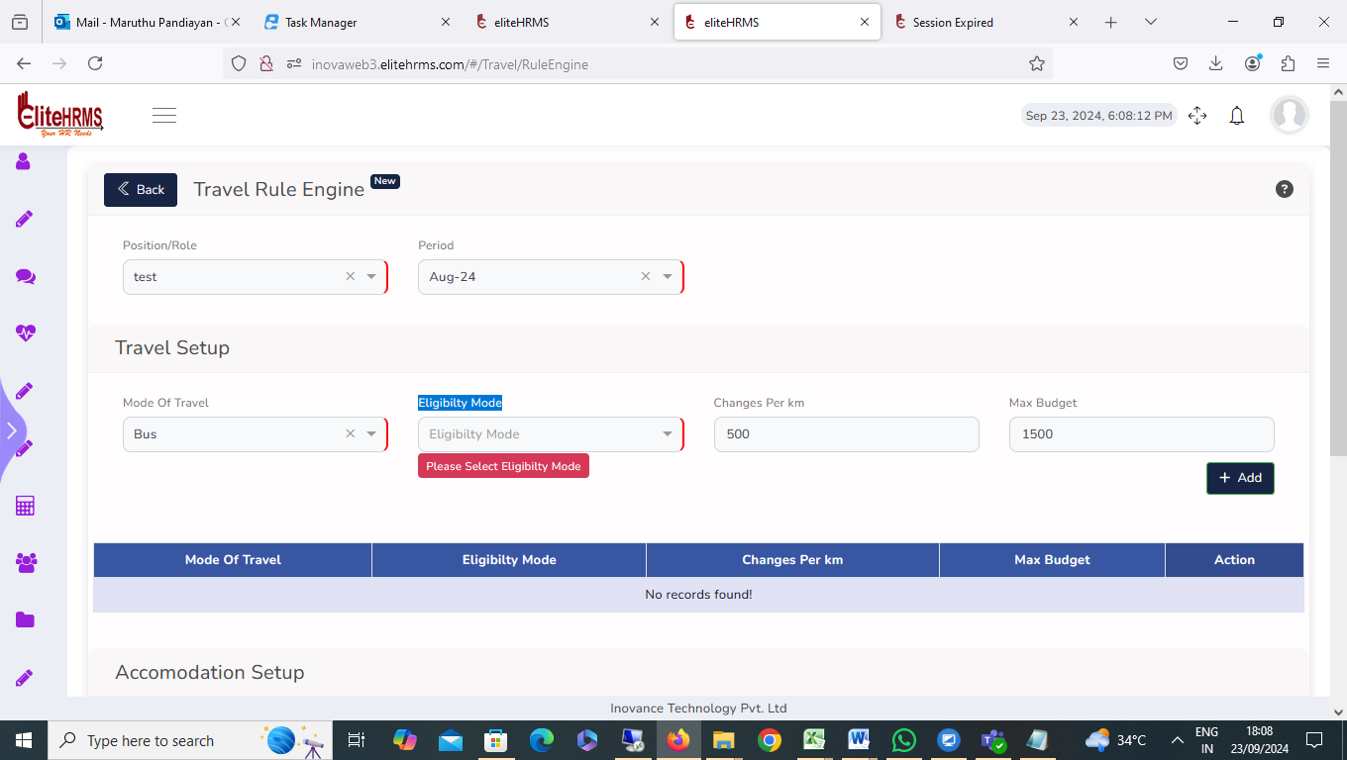
- Travel> Multi Currency Conversion: - Working
I have added Multi Currency Conversion entry data. Finally, the save button click is not working. Please check.
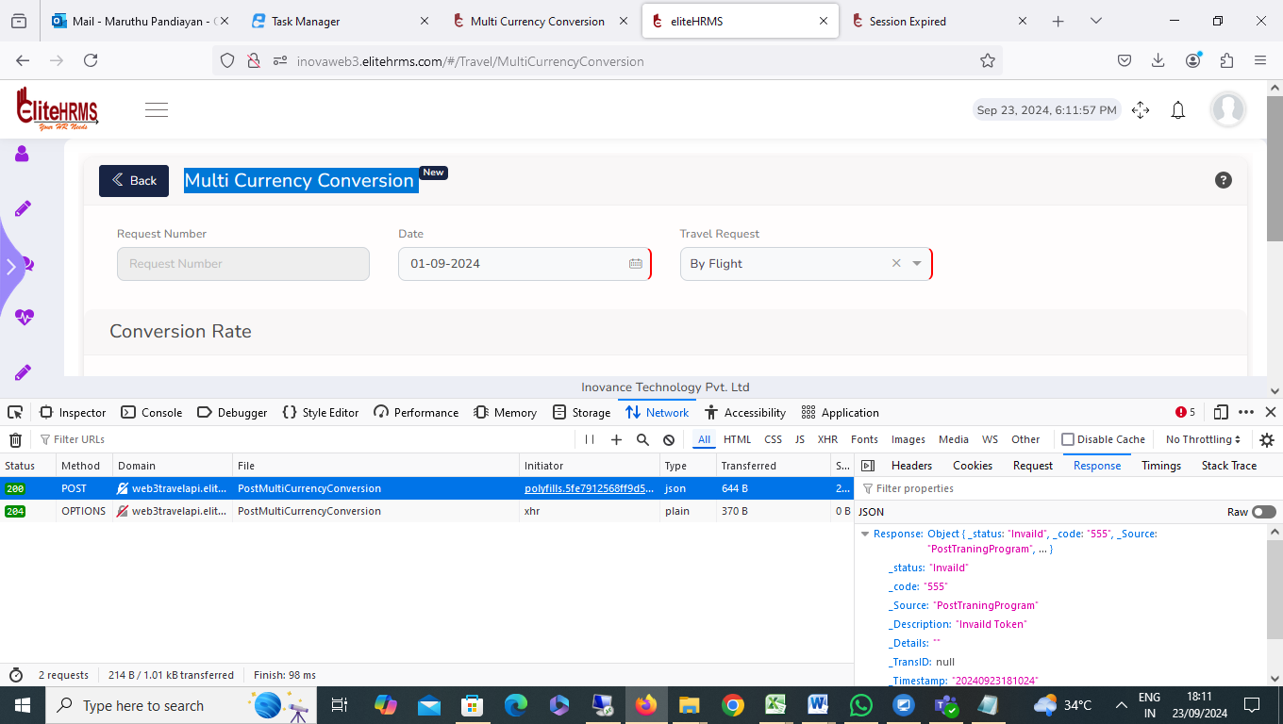

Response | Object { _status: "Invaild", _code: "555", _Source: "PostTraningProgram", … }
_status | "Invaild"
_code | "555"
_Source | "PostTraningProgram"
_Description | "Invaild Token"
_Details | ""
_TransID | null
_Timestamp | "20240923181024"
MultiCurrencyDetail | []
MultiCurrency | []

- Travel> Travel-desk: This screen was hold.
I have clicked the travel desk screen; details are not available.
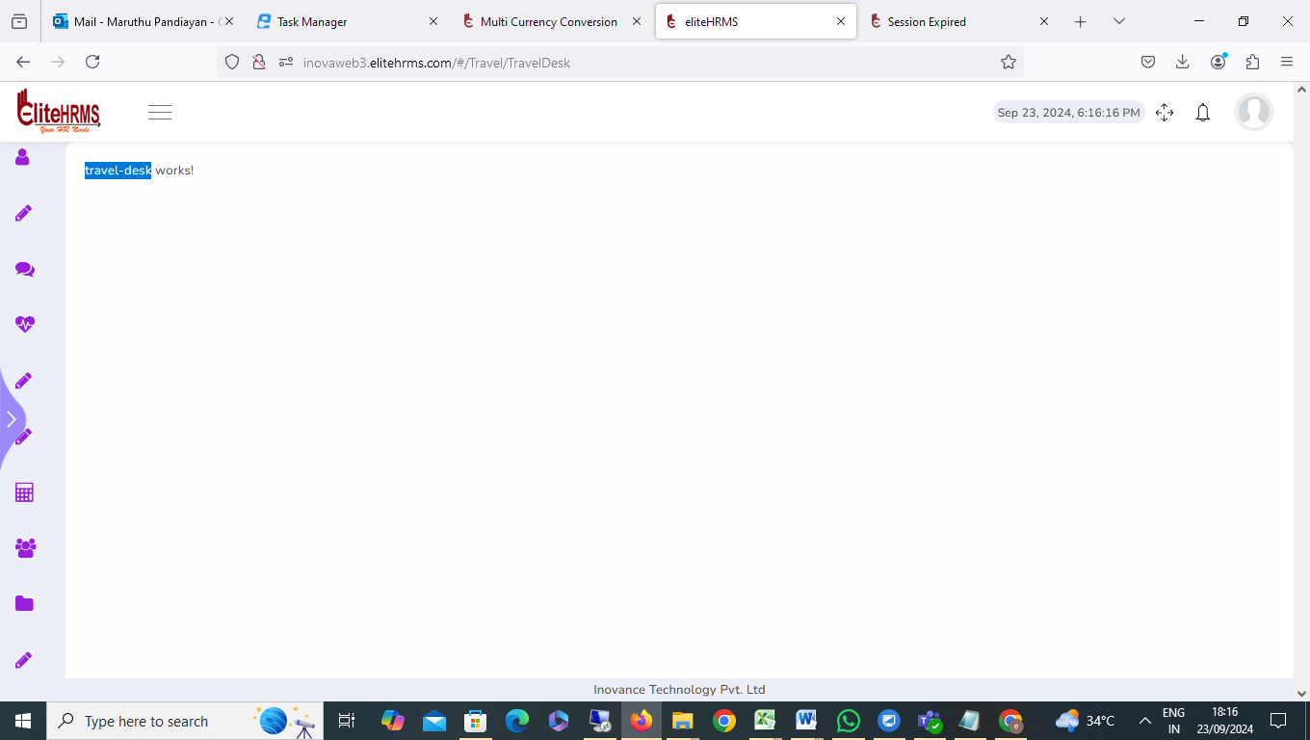

- Travel>Review Multi Currency Conversion: - Completed(deV)
The Review Multi Currency Conversion report filter options are not working; please check.
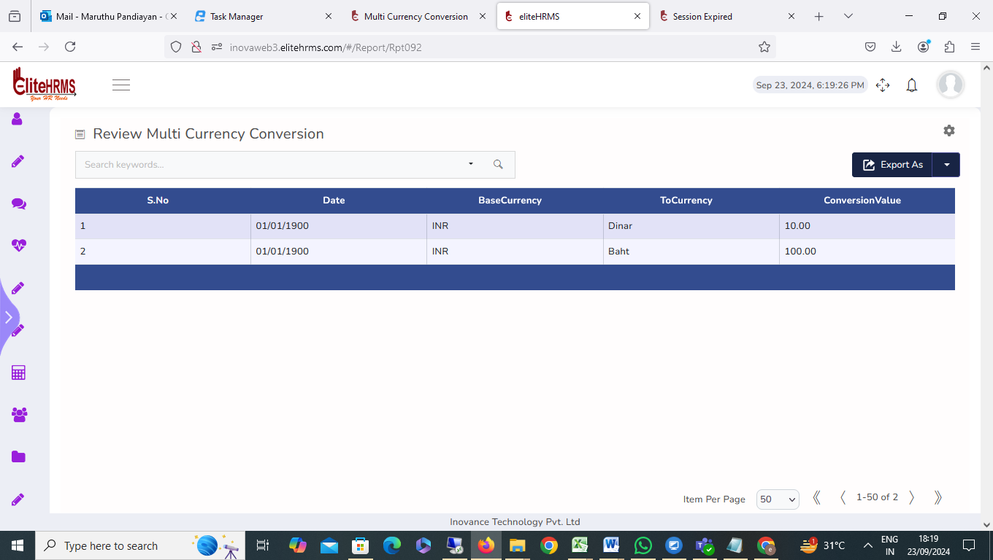

6. Travel> Review Expense Type:
The Review Review Expense Type report filter options are not working; please check
- Travel>Review Travel Request: - Completed (Dev)

- The Review Review Travel Request report filter options are not working; please check
- Travel Request Number details department name details visible. Please check

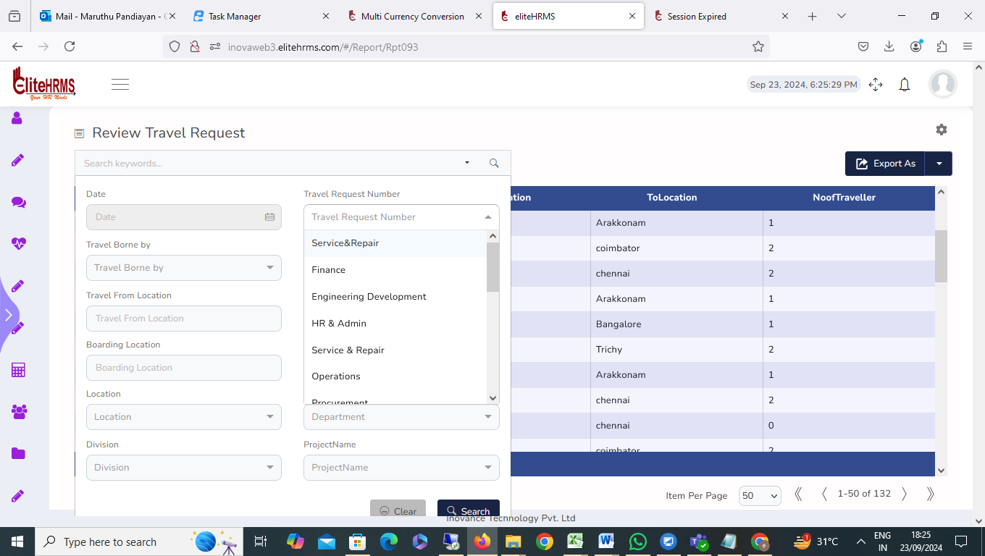

8. Travel> Review Travel Advance Request – Completed(dev)
The Review Travel Advance Request report filter options are not working; please check

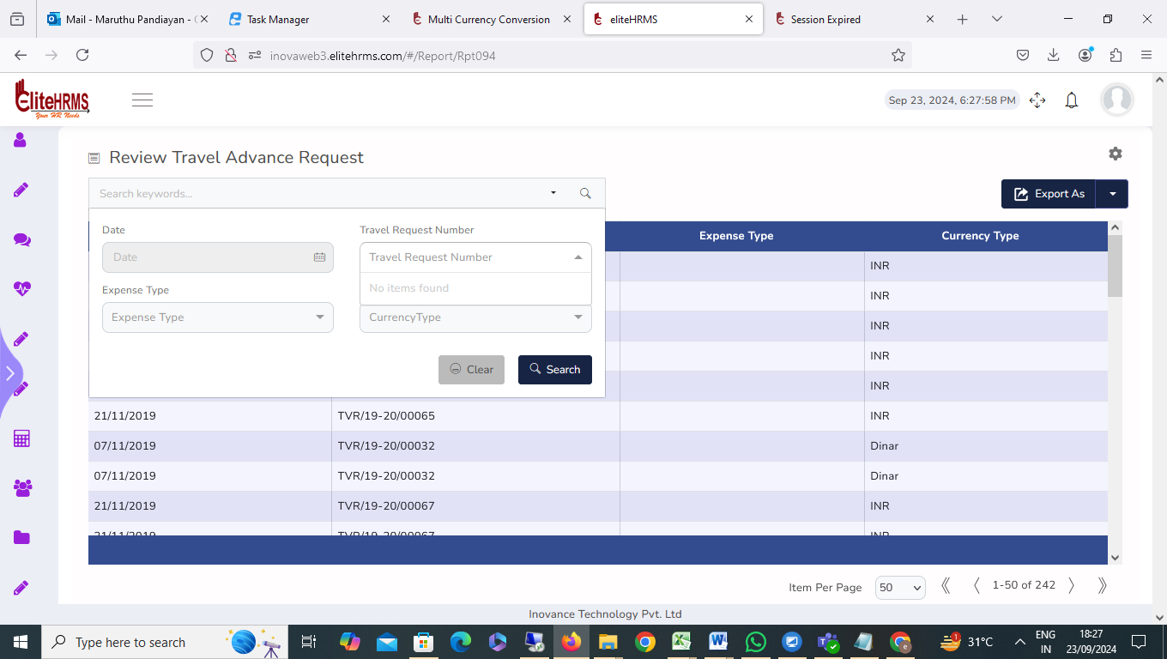

9. Travel> Review Travel Claim Request: pending(FE)
Review Travel Claim Request screen clicked application automatically closed. please check.

